BeaBook

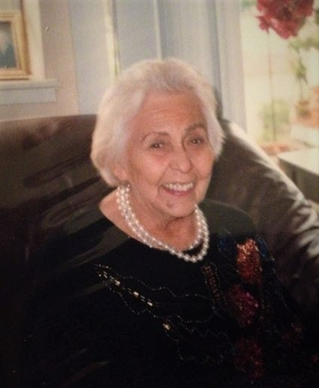
Beatriz Xochitl Larrondo Quintero
(2/2/1922 – 3/28/2016)

Forward

My mother was always an artist at heart. She painted and sketched constantly, creating hundreds of paintings and drawings. She wrote poetry and always created her own birthday and special occasion cards to express her love and share her wisdom.

When she turned 80, she decided to memorialize her family story as it had been passed down to her by her mother. She titled this trove of stories and drawings, BeaBook.

Mom was born in Culiacán, Sinaloa, Mexico in 1922. During her formative years, she was devotee of Lázaro Cárdenas, Mexico’s most beloved president who gave life to the ideals of the Mexican Revolution, expropriating large land holdings and nationalizing the oil industry. Mom never lost her commitment to social justice causes. It was with this conviction that she embarked on a career as an elementary school teacher.

At age 21, she met and married my dad who had come from Los Angeles to visit Culiacán. At that time, World War II was raging and soon, Dad was drafted and sent off to fight the Imperial Japanese Army in the Philippines. Mom came to the US by herself and settled in Redwood City where his parents were then living.

Part of the joy of reading these pages is in immersing yourself in Mom’s language which she learned the old-fashioned way, by osmosis from her environment. Her heart comes through in these pages.

Salomón Quintero
September 20, 2021

Prologue

From the scabrous mountain tops to the flat plains of the lowlands this book is written with love and a strong desire of communication. I want to pour in the little I know of my proud ancestors that would be of great importance to me as to you since we all respond to the same reactions of our land, atmosphere and consequently, our planet earth.
My extract is very simple, a little French, a little Spanish and some American Indian – or rather a very rich Mexican salad. After all, all salads are good if you add the best ingredient… love.
I have lived in the U.S. in a little city in the State of California for much more than half a century. But since that type of life is not common for you and me, I want to go back into prior times, places and anecdotes. I thought the best beginning for this would be based on my mother’s old stories of the Sierra de Durango, where her mother, my grandmother, Efren Fayette la Torre, better known as Efren Gonzales, came from.
We are going back to the 1800’s where one can really see the discrepancies that time can cause. Many people then had no schooling for lack of time, transportation and all the perils they faced traveling by foot or mule. And it was thought that women, the weaker sex, needed to stay home where they could be better protected. So they learned how to cook and sew. Sometimes the daughter of a wealthy man may have learned to sign her name and know her numbers, but teachers were expensive and inconsistent due to the inclement weather and so forth. Doctors were also very expensive and were limited to preserving life. Home took the place of school, entertainment, theater and dinners. No McDonald’s, no parks, no televisions, no trains, no telephones nor microwaves? No, no, no! After you have finished reading this you will be thanking God for all we have achieved in such a short time.
Now, let’s take a look back at Grandma Eulalia’s home. I hope you enjoy my stories while you take this trip with me, following the path of my family history.

The Three Sisters
There were three sisters - Theresa, Efren and Petra.
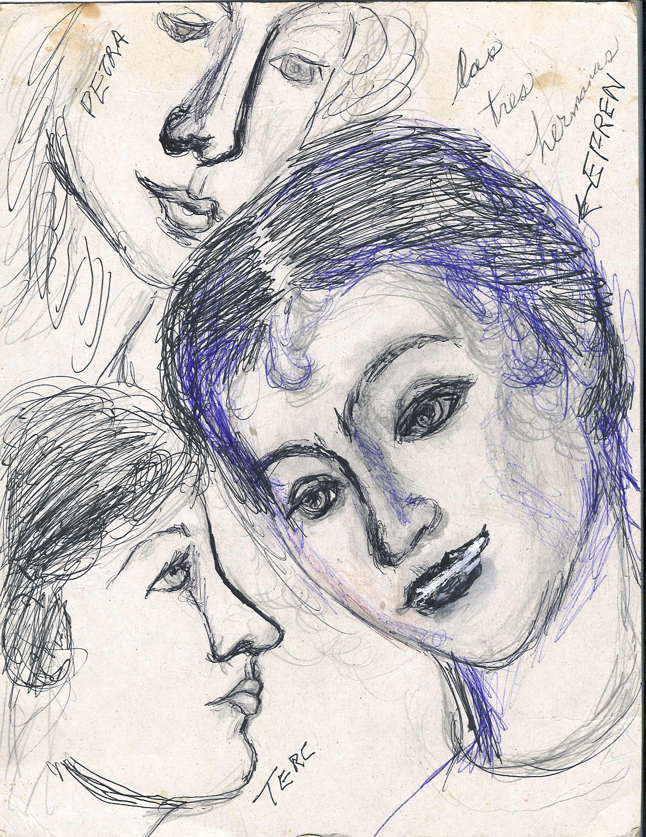
Efren was my grandmother. On some occasions, I skip the last letter in the spelling of her name, using the short Efre, and sometimes I use Efrena. This is for the sake of style though some may think this is only a man’s name. Theresa is sometimes referred to as Tere. These changes are merely made affectionately, as an expression of my love for them.
Because I love all people it does not matter how they spell their name, the year they were born or where they came from. After all, aren’t we all from planet earth? If you agree with me so far, please keep on reading for this book comprises a segment of the encyclopedia of life.
And so with lots of love and emotion I’ll cut to episodes that reflect very clearly the cosmic one station after the difficult life offered by the roughness of the Sierra, the high mountains. These stories leave us with the opinion that if we could design our destiny we’d select a paradise more gay, more safe and advanced, with very well developed methods, clear beautiful lands, pure hearted people and the blessings of God. Now I am at your mercy for a better opinion of my book. I thank you for accompanying me during this precious time and may God bless you with a great time, good life and amor.

Arriving at Grandpa Luis’ Hacienda

There! Standing by the front gate, was a clear vision of good old grandpa Luis. With tears running down his face, he anxiously awaited the happy arrival of the newly orphaned girls - his three sweet young granddaughters. As they came closer, he hugged and kissed each of them madly. 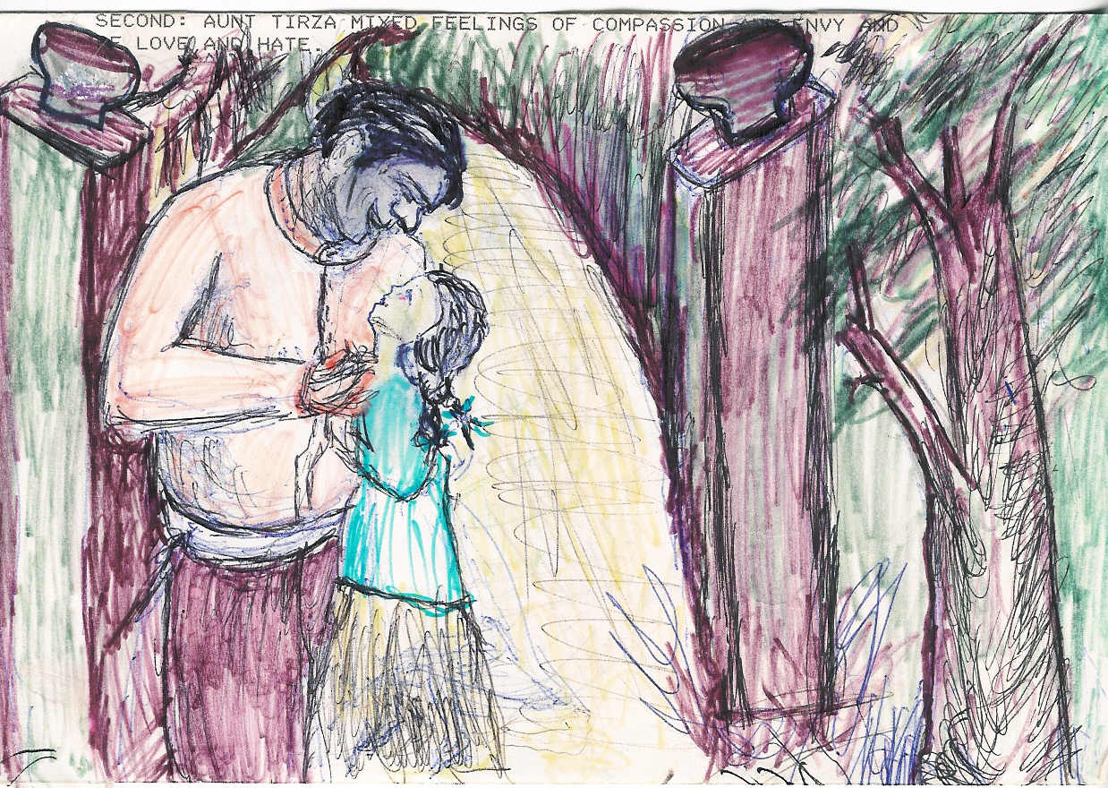 First, little Tere, then Ephrena, and last Petra. Then he introduced them to Molly who took them on a grand tour of the Hacienda. They began with the sugar mill, then aunt Tyrza's quarters, and finally, to the guesthouse where the three would reside. 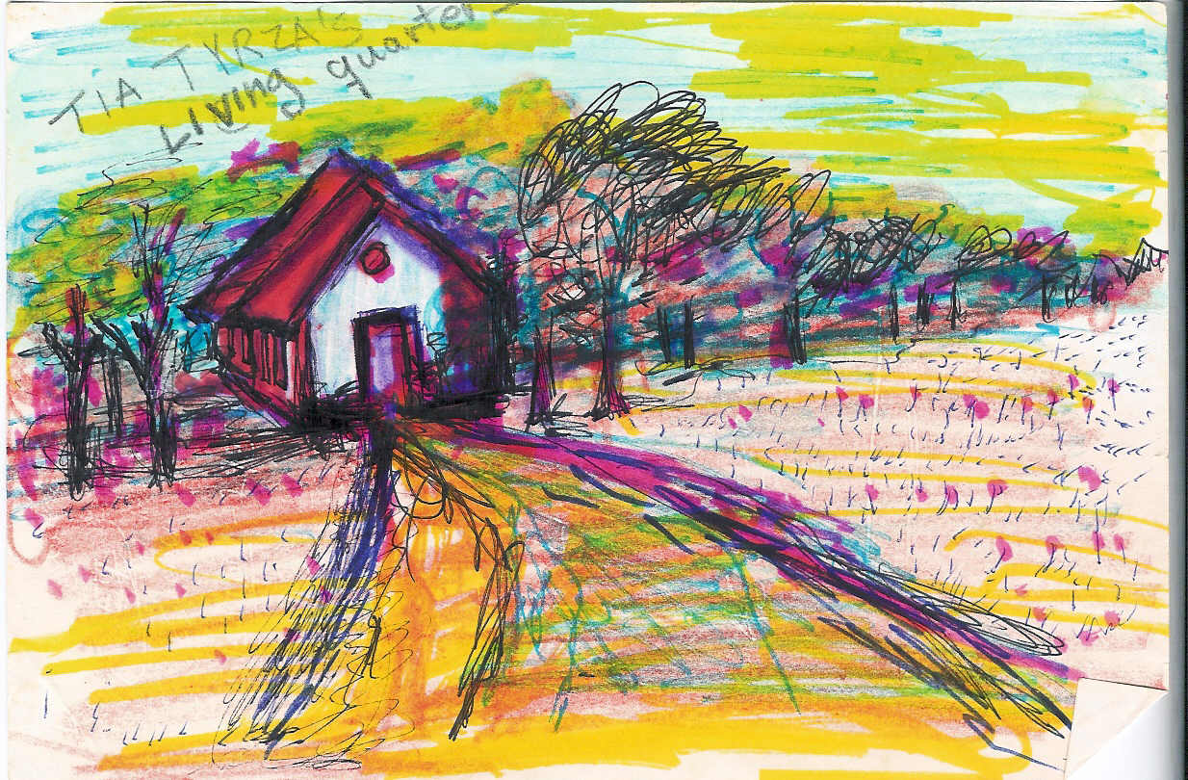

As told by Efren: The following morning I was awaked by a loud shriek coming from my sister Teresa. The room was dark, so frantically I threw aside my covers and jerked out of bed to see Tere’s silhouette by the window. I pulled open the Persian drapes and opened the two sides of the long, narrow window, as a gush of the sweet-smelling molasses, freshly made in Grandpa’s little sugar mill, came up and embalmed the room air. The view from the window was an array of colors, a display of hues lighting the sky with yellows and pinks, blues and soft oranges.

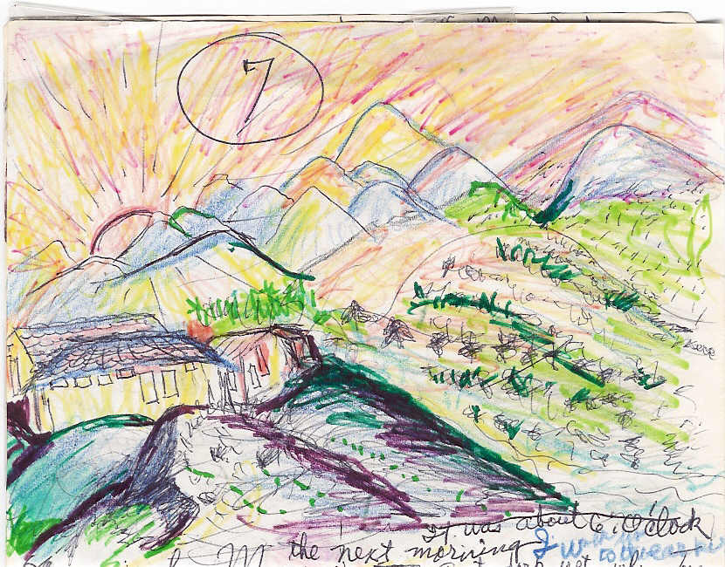
From afar we could see some of the sugar mill workers. They had on leather aprons and their heads were tied with bandanas.
Standing there was Grandpa Luis opening what appeared to be a box of tobacco. These were the very first things I saw at the old hacienda and they stayed in my mind as though engraved in stone.
NOW ABOUT MOLLY... I never really knew much about her real name, but I suppose that it was Mary, or Maria for she was born in the old hacienda where her mother was the cook. When her mother left, she was baptized with this alias name, Molly, meaning “the owner of the mill” or “molinera”. This was not done legally, only as a gesture of love. However, psychologically, it played a strong part in her mind and character for she assumed such a position.
AND ABOUT AUNT TYRZA… Aunt Tyrza was second after Grandpa Luis in rank of ownership and authority, yet sometimes he took the advice of Molly. Tyrza felt sickened by an intense feeling of challenge. And although the memory of her dead sister, Georgina, brought tears, and she was able to find consolation and compassion at the sight of these three innocent faces, she also felt threatened by them now entering the picture of her life. She found her soul in conflict with envy and hatred.
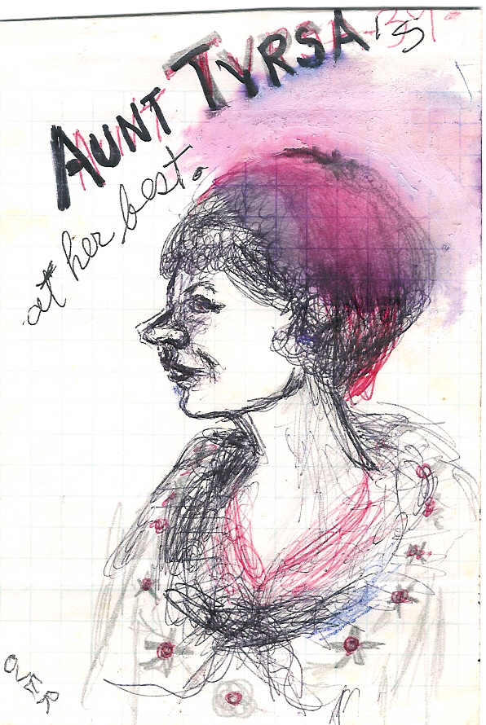
DAILY LIFE
Aunt Tyrza encouraged us girls to bathe in the river, which was down a steep cliff. After three or four times of going down the cliff, the feeling of being scared began to subside. Life was glorious going down to bathe and play and swim all day. Supper? Oh yes, we had our own bowl of soup as Efrena would happily say of all the fruit we could pack in our bellies; apples, apricots, cherimoyas, anonas and sometimes even bananas or plantains. No dietician was ever involved in our diet. Although we were healthy, our hair was getting brittle from the inclement weather. Tere's toenails grew long and there was no one to clip them, but they were handy when climbing down the hill. It seemed that God protected us against the new environment. The brightness of the sun and the cold effect of the air brushed Efren's soft pink cheeks and they looked now like two red apples against her freckled face and black hair. She was a picture of beauty and health.
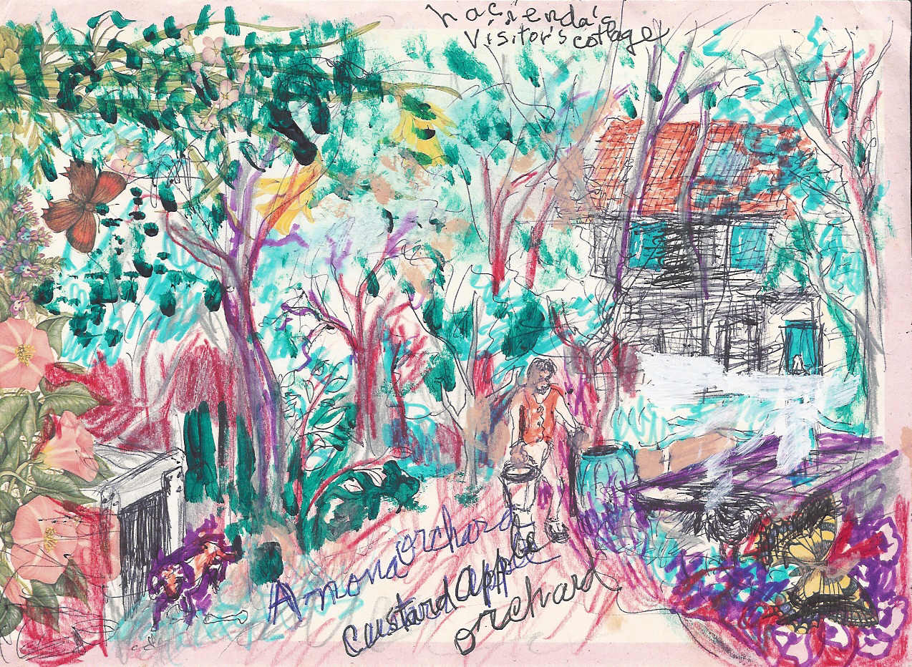
Petra, now fourteen, seemed also to be taking advantage of the cold air and altitude to improve her disposition. That and the combination of the hard exercise going down to the brook made her red hair and her bony legs grow.
As for aunt Tyrza, she kept on wishing for the girls to go further away from the house and go more into the wild style. She suggested that while bathing they could do some laundering of their own and more. So, time went by and we three sisters were going through lots of changes in our patterns of life. Aunt Tyrza’s demands were increasing each day. We were supposed to fill up ten bushels of picked fruit before ten in the morning, with breakfast at ten thirty.
There sat a large picnic table with piles of fresh fruit and a pitcher of milk. A man came over on a mule from afar to deliver the milk each day, for we didn't have any cows in the entire area. We loved milk but had to abide by the thrifty suggestions of aunt Tyrza. “Have a big mouth full of fruit and a teeny weenie drink of milk,” she would tell us. “Remember, I have to buy the milk and pay for it.” And we answered, “Yes Aunt Tyrza.”
One morning, and I am sure it wasn’t my day, I tripped over the pitcher and all the milk was spilled on the floor. That triggered all of Aunt Tyrza’s moods of capataz (wicked mean warden). Before I could apologize my back was full of welts from the belt she used on me. My face was washed with tears and my heart was torn with pain. “Tonight, you skip supper,” she said as she left. Neither she nor I ever talked about anything else, it seemed.
That opened the door for Aunt Tyrza to use the whip on us. In a frenzied mania she began doing it every day. When Molly questioned her strange behavior, she proudly responded, “I just want to educate them.”
MORE ABOUT AUNT TYRZA… she never had children of her own. She never got married or even had a boyfriend; she was a hard worker and a very religious old maid. She took upon her shoulders most of the responsibilities of the entire household. She did lots of good things for the church and their believers. She did the payroll, for she knew how to add and count the monies. She was sweet to the peasants and the clergy, and every month they were invited to stay for the different ceremonies that were done in our hacienda for the workers.
We were dressed with clean garments and helped with the preparations and for that we were praised, and punished for whatever she thought we didn’t do. We were growing accustomed to her bizarre character and we went on doing our normal routine of things like picking fruit in the mornings. In the afternoons we would go down to the brook and wash clothes, swim and play. We had a bit of good times.
We went to visit our closest neighbor, which had a nice French style house, a chalet, about three or four miles away from our place.
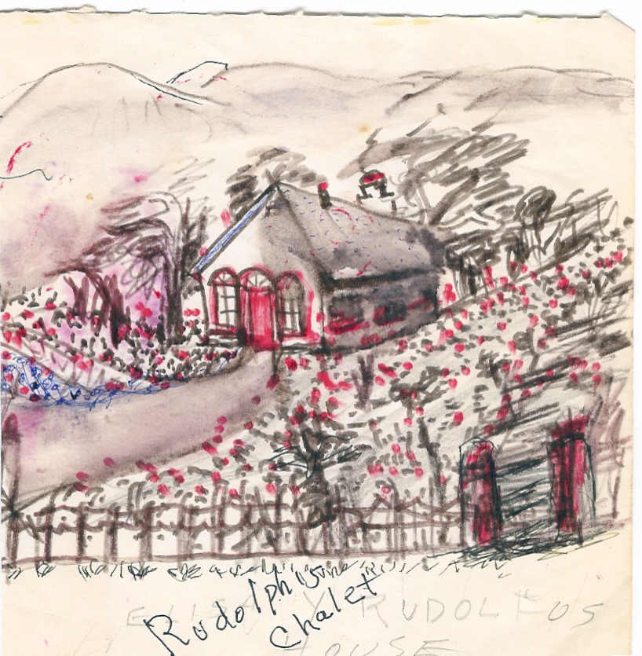
Aunt Tyrza had her own horse and dressed in proper riding attire. Her knee-high leather boots, a leather jacket, a pair of bombachos and her hat. Teresa dressed like her Aunt, the rest of us had on a long skirt, black shoes and a cap. Petra confected the skirts for us. We were so delighted with this special occasion; we had never worn shoes or had been dressed up in all that fancy stuff before. When we arrived at the end of our journey and our horses were secured, the owner of the house came to welcome us. He kissed Aunt Tyrza’s hand and smiled at us saying, "This is your house, welcome."
His sister came out when we were about to enter and welcomed us too. We began an amiable conversation and learned that since her brother, Rudolfo, had become a widower and she too was alone, they had decided to come and live in the beautiful Sierra de Durango to sweeten their lives. She wanted to become our friend and meet other women of the area. We were served some milk porridge and freshly baked bread, still warm from the oven. The rest we were welcomed to take home. We enjoyed our trip so very much.
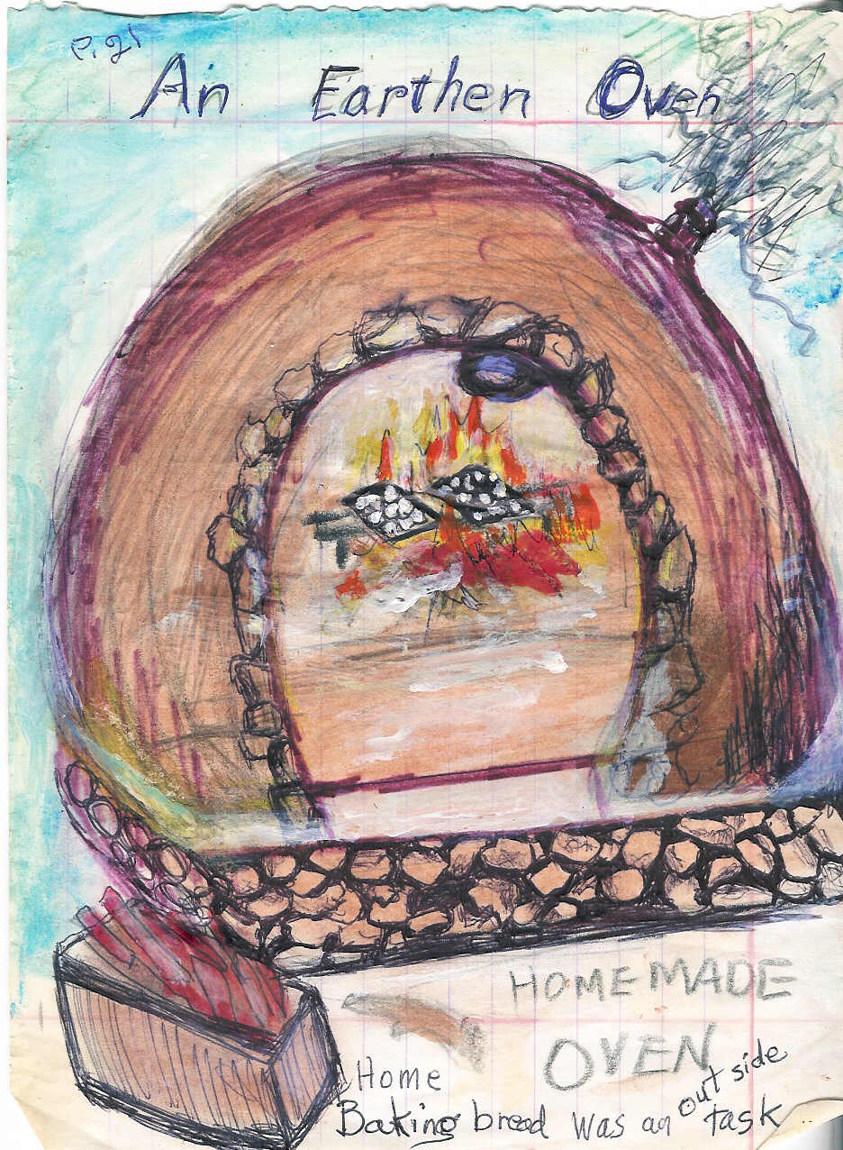
Aunt Tyrza talked all the way home about Rudolfo, the widower neighbor. It seemed as if in the back of her mind she was beginning to concoct a fancy between she and he, and so she invited them to visit us for coffee and bizcoches.
The following week she looked like a new person; she had a happy face.

Rudolfo and Elisa soon came to visit us driving a carruajillo (a chariot). She was wearing a burgundy shawl, a brown skirt and black sandals. They met our entire family. I couldn't get over the strong affinity between Rudolfo and Molly.
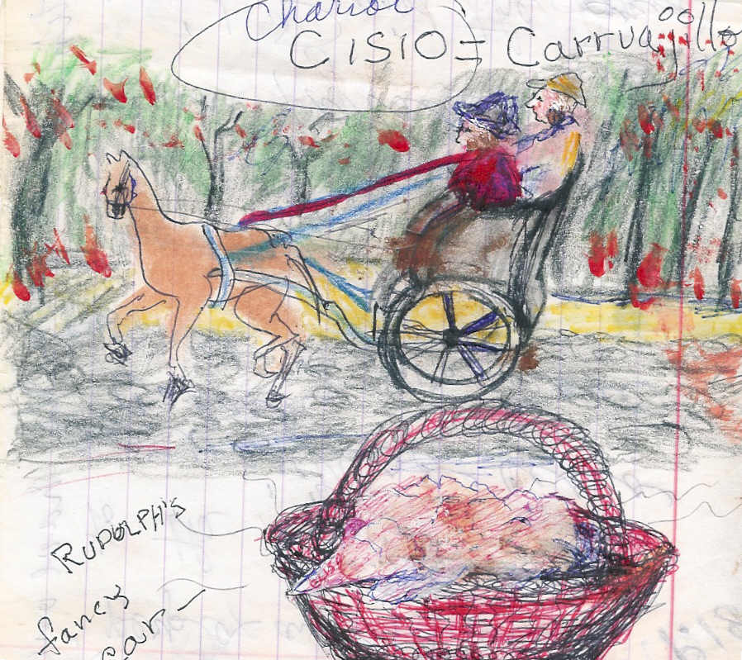

EFRENA
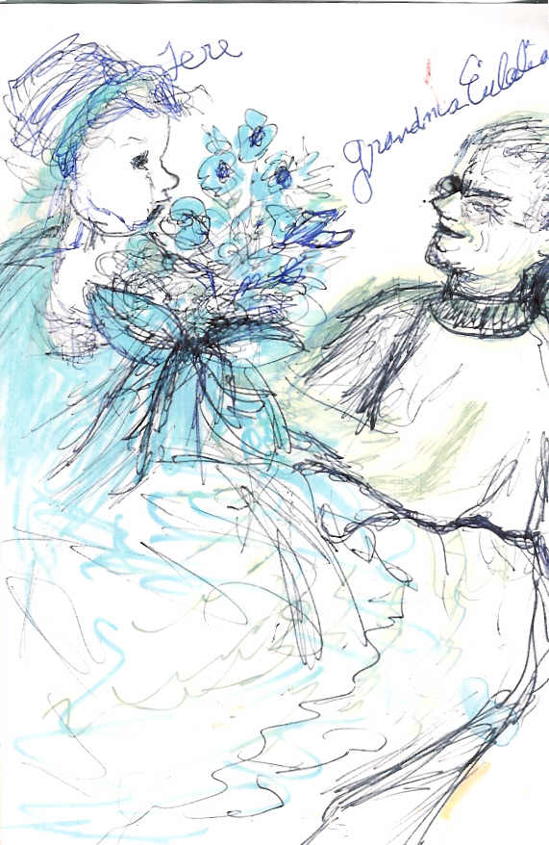
The following morning I was feeling sick. I threw up the night before and now had a fever and a headache. I told my sisters that I wouldn’t go with them until I felt better. When Aunt Tyrza discovered that I wasn't up she didn't want to listen to any excuses and used her old belt to beat me right there in my bed. I was sobbing when she left the room. I got up as best I could, picked up my new skirt and new shoes, made sure no one was watching me and went out to the road which lead up to the river. The river was very active at this time of year, which was summer, so I had to swim across it. After an enormous struggle, I made it to the other side. It wasn’t easy. As I climbed out, I was gasping for air. There, on the other side was a lady who recognized me. She asked if I was Efren, Tyrza’s niece. I told her what I was going through and she understood exactly. She comforted me and took me to her house to give me dry clothes and a cup of warm tea.
The next day, my Grandmother, Josefa Eulalia la Torre was found dead in her bed. She had died of old age and a short illness; she was 89 years old.

Everyone went to the big house, including my newly found protector. She wrapped me in her old blue shawl and returned with me to my family. No one believed her story of my near drowning in the river.
After the grandmother’s funeral my father, Felipe la Fayette Gonzales, and my brother Miguel arrived at the house.

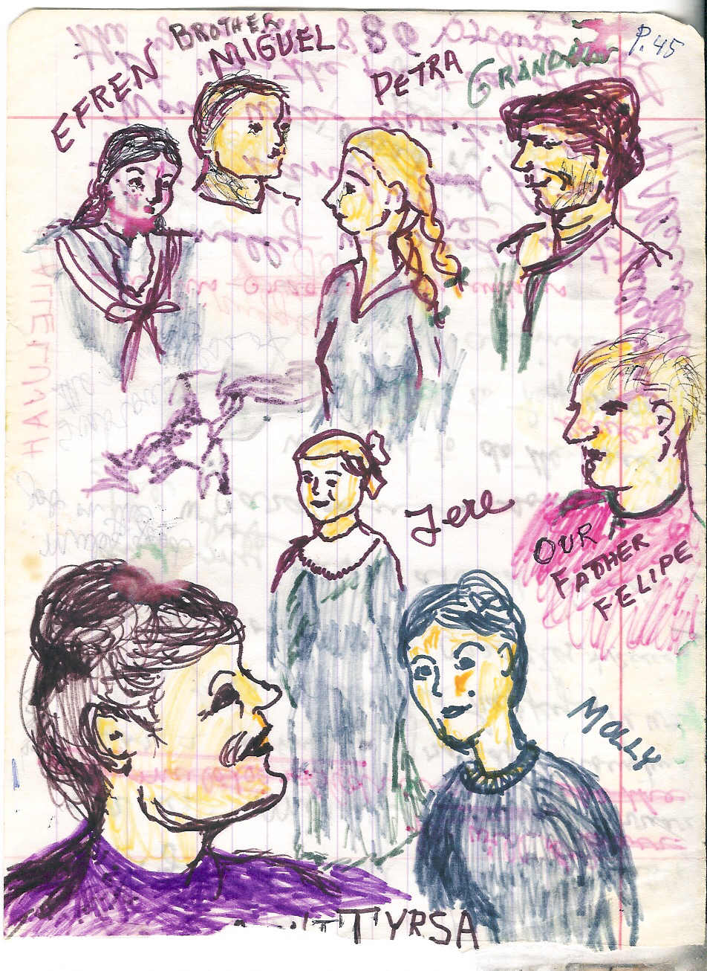

Miguel was now fifteen, tall and strong. I made sure that my skirt covered my sores and bruises.
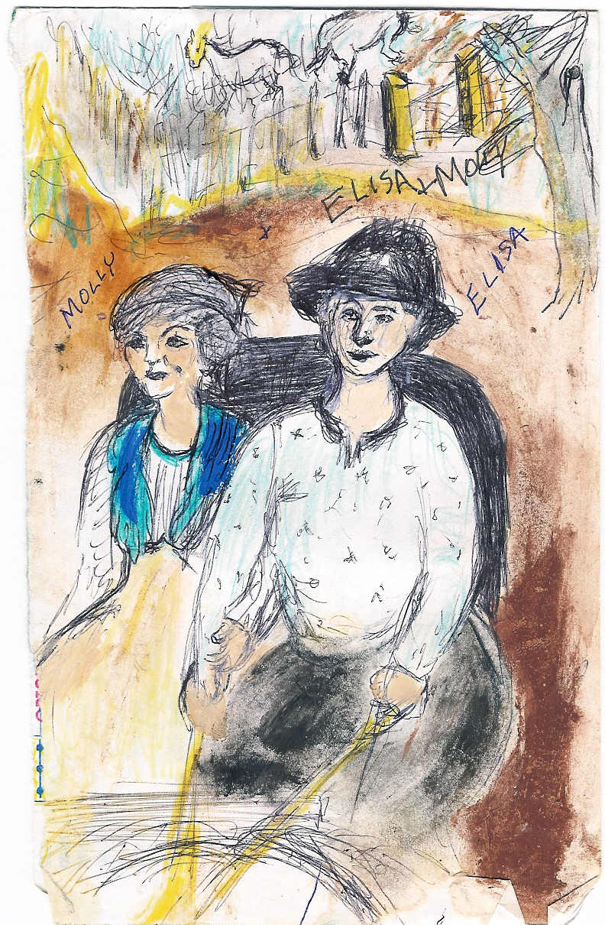
It didn’t take long for Rudolfo and Elize to understand that aunt Tyrza was unhappy with their presence. This only precipitated the fresh new relationship to go into a quick nuptial engagement. Grandpa Luis agreed to reverse the situation and so, Molly would go visiting with them and so every Monday for a few hours on Molly’s day off she would visit. So everything worked out just right.
So the engagement and the nuptials of the couple took place sooner than expected. Petra designed the bridal dress, using the material donated by father who was a vendor, "viandero”.
Father would travel far distances to other towns selling his wares. It was a rough way of making a living and especially hard leaving the family behind. With others this presented a problem. Father would take my brother Miguel on these long and hazardous trips and often the mules would get sick which added to more challenging problems. Miguel would go on these trips and learn the trade from him. Father was rewarded with his companionship and help.
Petra was self-taught in dressmaking and design and sewing came in very handy particularly when it came to sewing Molly’s wedding dress. Efrena would say, “When it comes to sewing, I would die, for I can’t sew a stitch”. She didn’t share Petra’s talents. Efrena’s talents lie elsewhere; she was athletic, she could swim and jump very high. She once swam in the river against the currents. For not having a formal education she was like a human computer designed for the use on math. Teresa’s talent was in dancing and singing. La Bailarina she was called.

Aunt Tyrza had sprained her ankle, so that she would not be able to attend the wedding, let alone help with the festivity. Was this a plan? Right on the day of the wedding, we took turns applying hot compresses to her ankle. Grandpa Luis hired a lady to stay with her.
The wedding day brought a surprise. We discovered that we had two cousins, Liliana (which was also our mother’s, mother’s name) and Georgina (named after her Grandmother, who told us about her mother, a great gourmet cook.
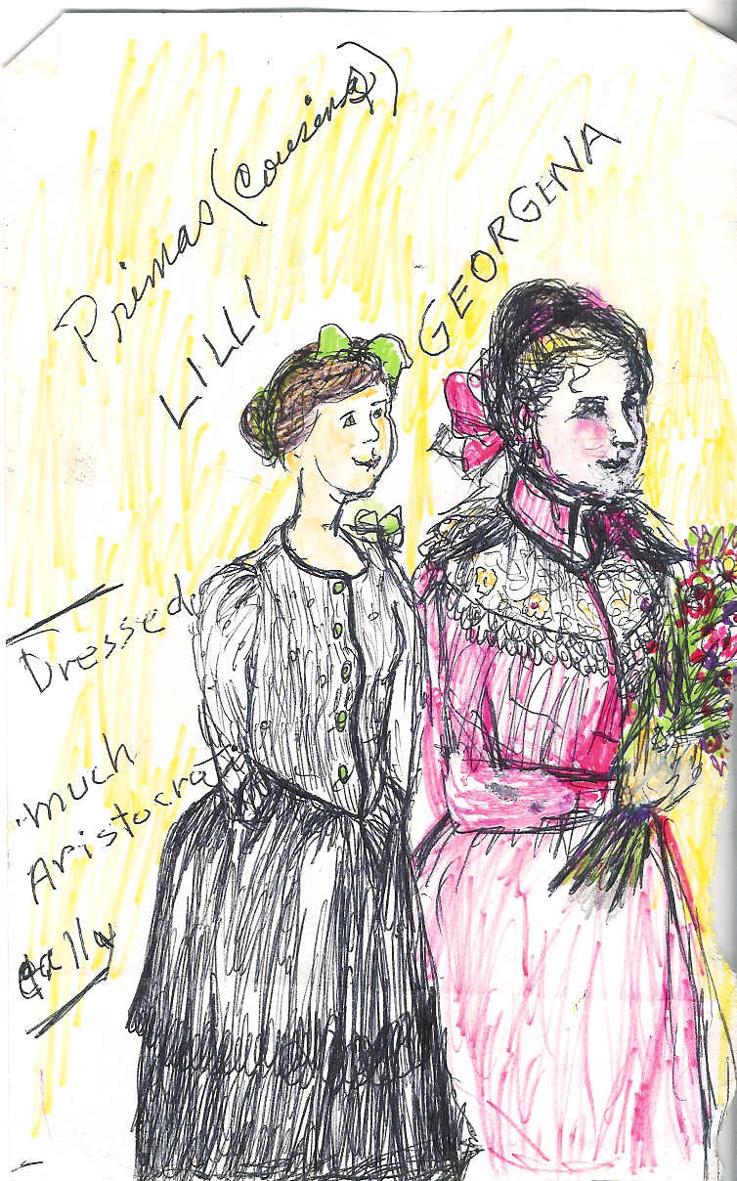

The wedding also brought along a wonderful time and many new things for us to enjoy. It was the first time that we had cranberry medley and smoked fish. The fish was cooked with orange and brown sugar and was served with the traditional drink of chocolate. Everything was served in abundance.
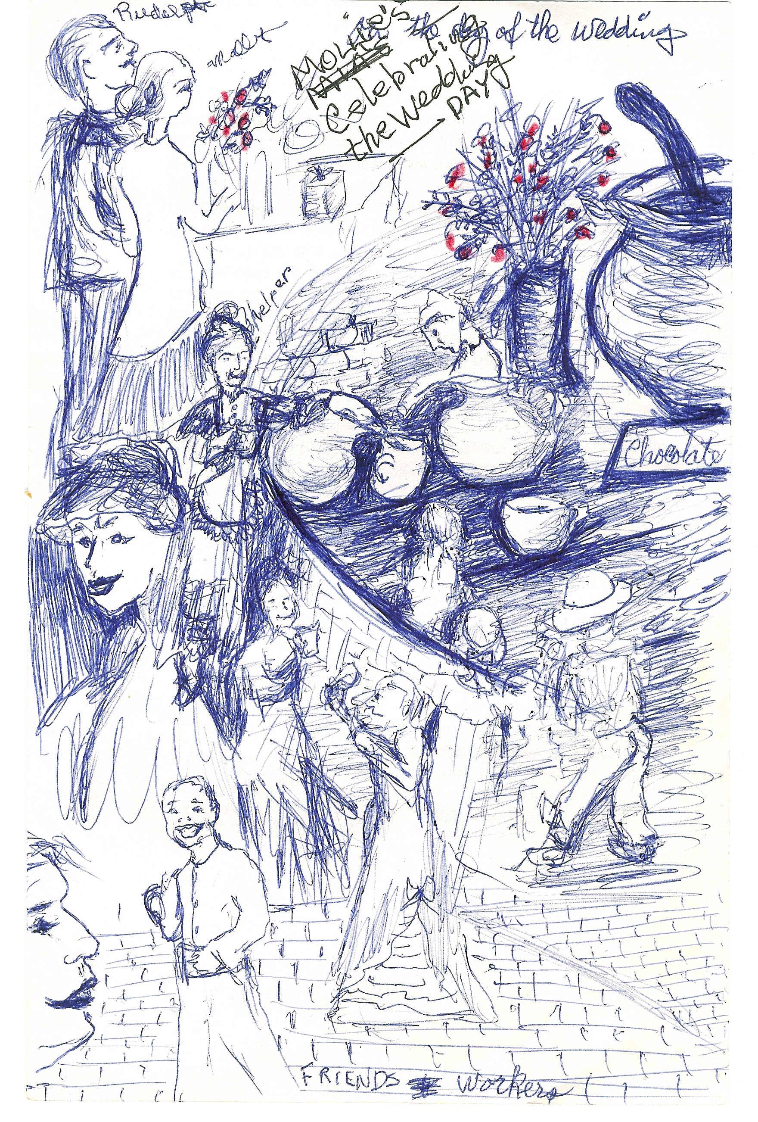

After the wedding, the bride and groom drove away and we went into the silence of wonderment.
And so the days came and went and suddenly it was the end of summer. The trees were fruitless. So I decided to go down further and look for fruit. As I got down a small clearing where horses once had been, I discovered a little trail. This trail led to a shack. As I approached this shack I heard a low tinkling noise. In wonderment I looked again and this trail led to a storage room, “Tilliches” the old trifle room.
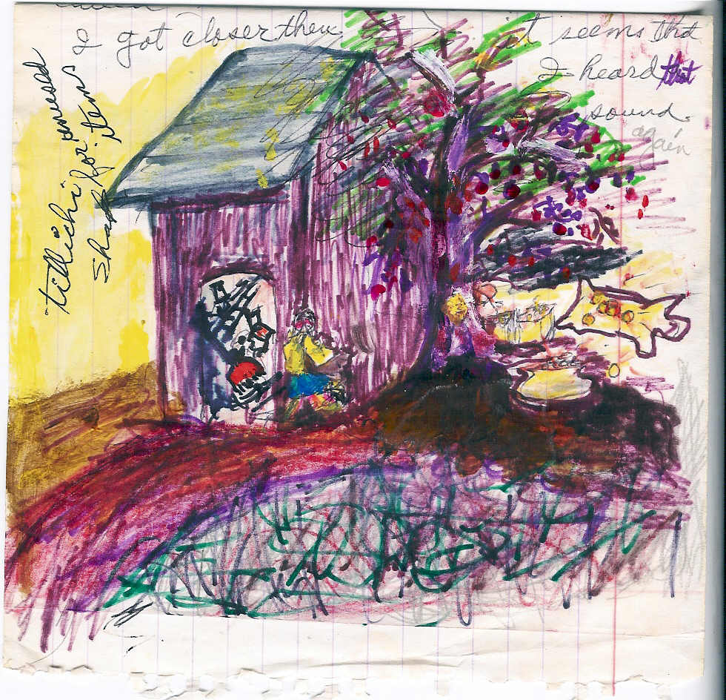
As I got closer still, I heard the sound again. There was Grandpa Luis, placing bright coins in two large cans, which he kept in the ground. The coins were round, beautiful and so shiny!
I held my breath and hid as best as I could, for I feared Grandpa was doing something very private and that I might ruin his entire project. I waited and waited as he kept buffing those wonderful looking coins with a cloth, then returned them to the can in the ground. After he was done he would place more coins in a pot that he kept outside of the hole and the same process of polishing went on and on. I didn’t even move for I was afraid of making any noise, but I had to leave before anything else happened. So I returned to the house and no one ever knew of my discovery.
About a couple of days went by when Grandpa Luis went out to take a mule to some friend. My sisters were eating and I was supposed to fetch some water. Instead, I went back to the place where I saw those bright and beautiful coins. There was the old storage shack, now an arandano tree stand out in the area of mystery. The hole was now covered. I could tell that he did a good job at covering it and then topping it with leaves and then two long drafts of wood. It was so very mysterious now. I went back to the house bringing with me a bucket full of water. All of these strange happenings were left there in a state of wonder.
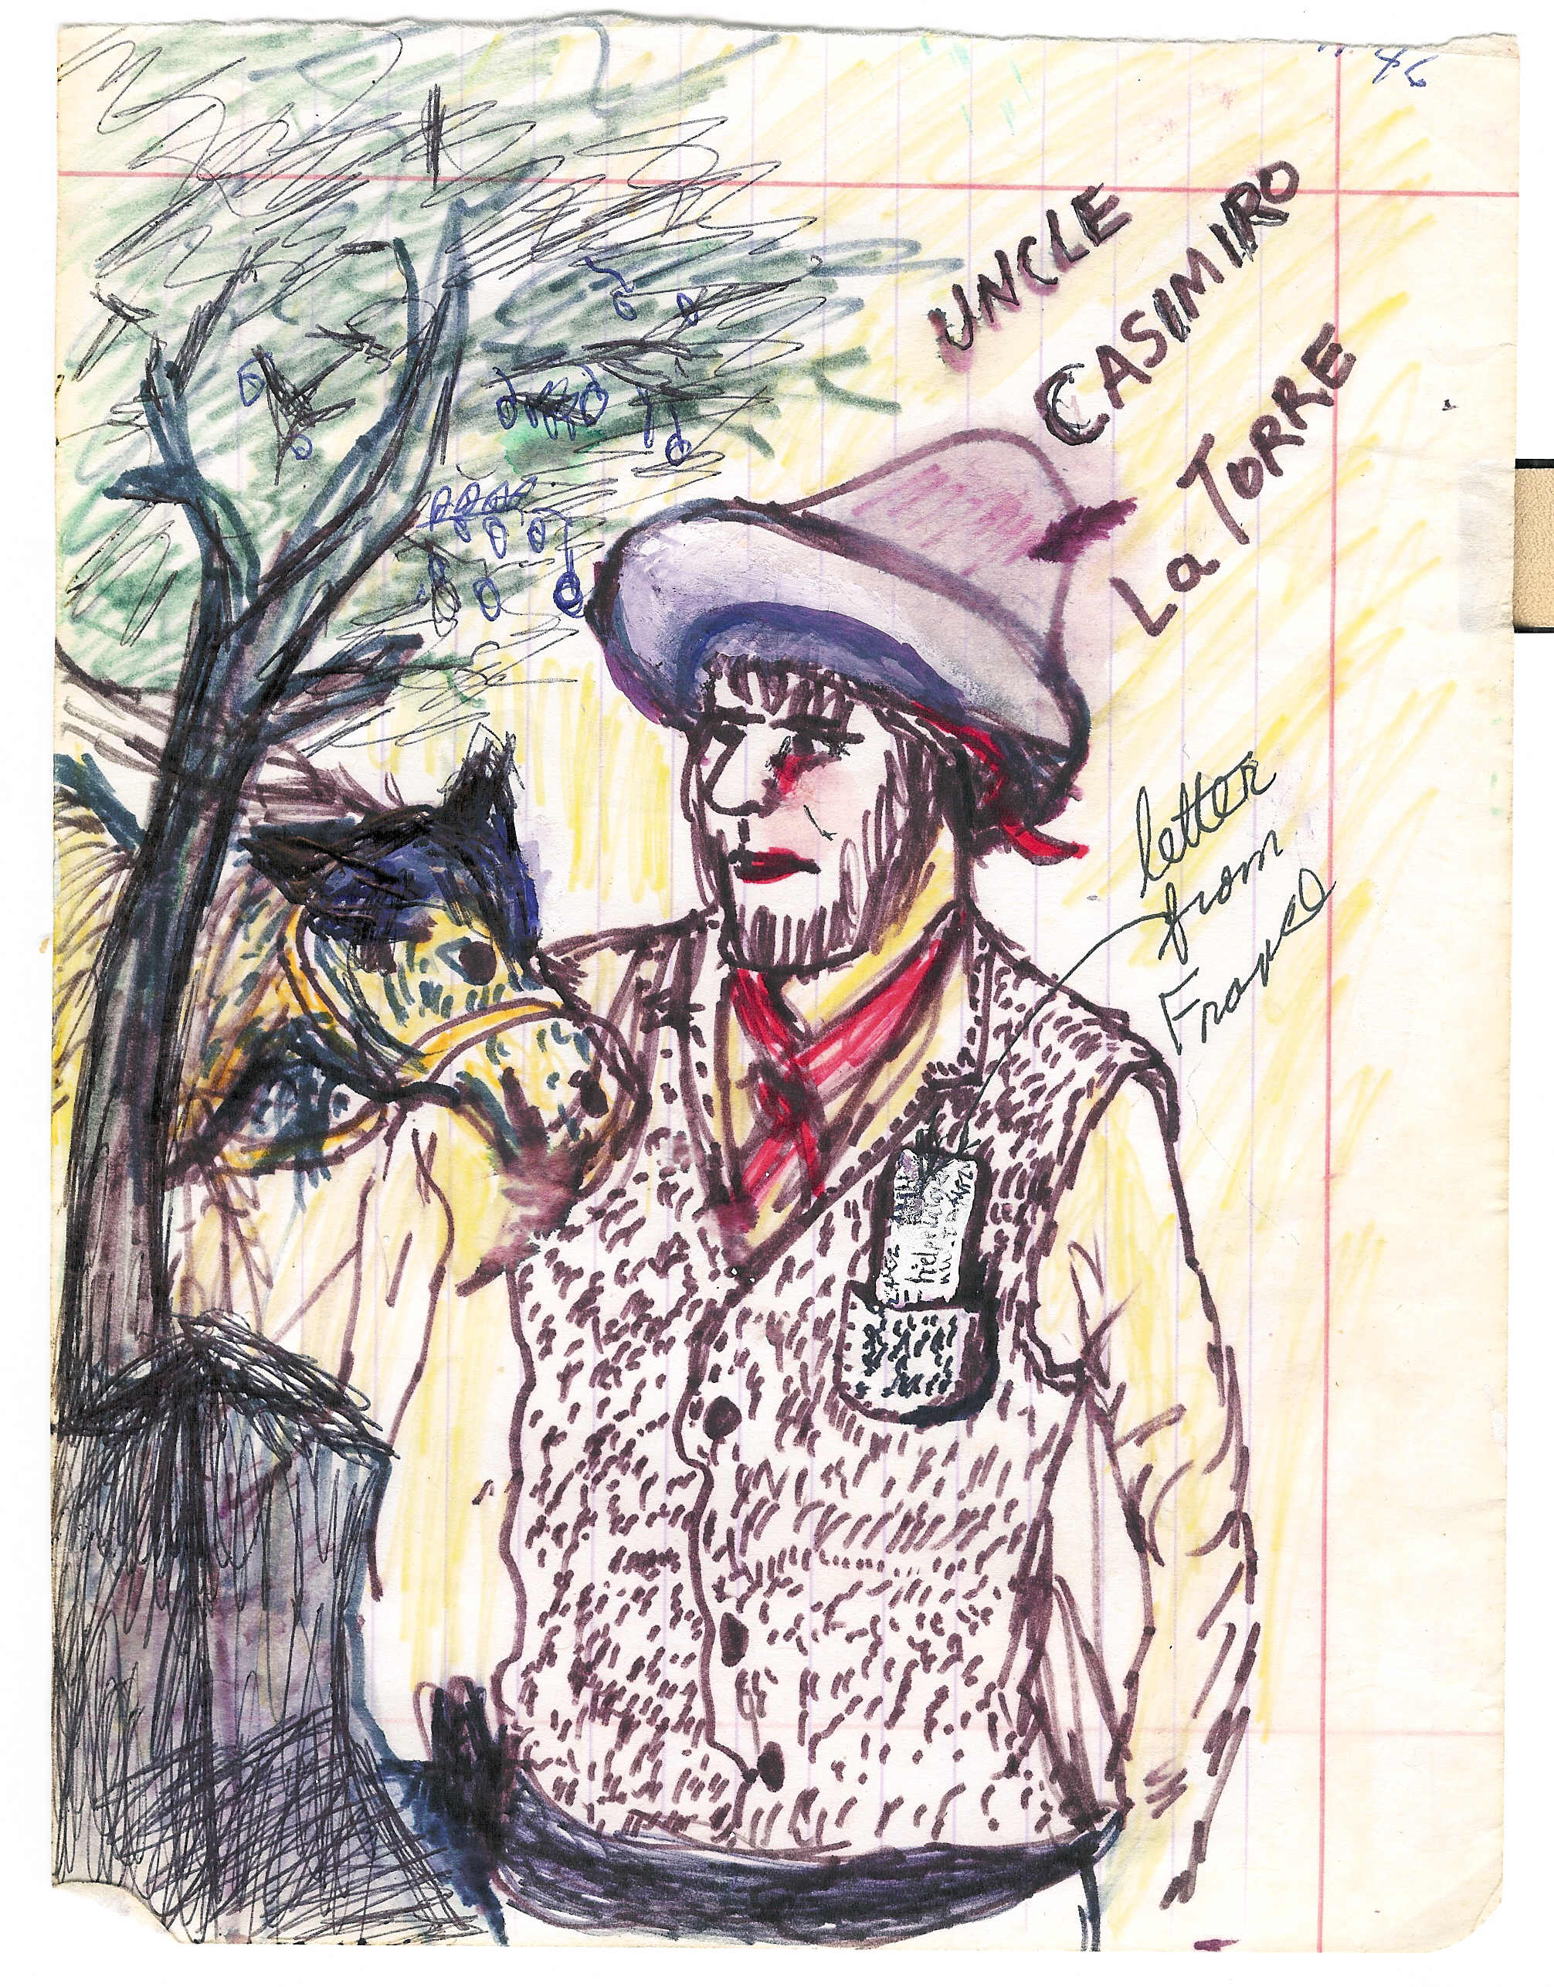
About six months passed after the day of the wedding and all of those things were long forgotten. Uncle Casimiro came in bringing a letter for us.
Grandpa Luis brought him in and served him a drink of aguardiente. They were chatting happily when Aunt Tyrza appeared on the front porch. “Here dear daughter, read this letter." grandpa said anxiously. Now, we knew that French people lived in France. But our villages were all we knew. We lived together without ever asking about things of faraway origins. It is true that many Spaniards have settled in our towns and later on many Frenchmen found refuge among our hills after the revolution. We also knew that the real natives were there long before and we also knew that my father’s last name was Lafayette. He never used it; he used Gonzales after his mother instead. Lafayette means in Spanish “fallo”, suggesting a little crazy. So he adopted Felipe Gonzales instead, or just Gonzales. We were known as the Gonzales sisters.
Father had a brother, Samuel Lafayette Gonzales, who lived in France. He had learned about us and knew of our misfortune. So he wrote us, asking for my father and the family to send us to France to become his heirs. He said that he had a big estate and when he passed away, all of the property would go to the government. After all of the excitement and commotion and long discussions, my father and the rest of us accepted the idea of this proposition. He figured that it would be very positive in all ways for us. We agreed also to the idea of this new venture.
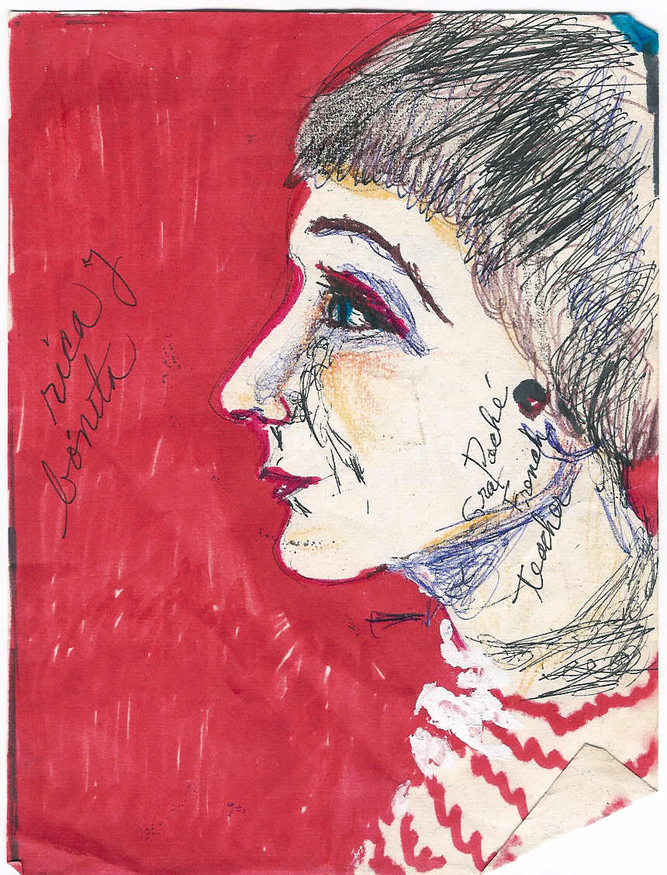
The very first thing we had to do was to learn how to sign our names. Secondly, the proper apparel: good shoes, several skirts, two different blouses for each and so forth had to be made for each one of us. We had to learn to comb our hair up high and learn to brush our teeth. We got three little brushes and a big bag of baking soda for our oral hygiene. We had to learn how to wash our hands and faces and to eat food sitting down at a nice table. We had to learn table manners. We were each given a fork and knife so we could learn to cut up steak, etc. They bought us pencils and paper to practice how to sign our names. We were immersed in an ocean of new ideas and styles. Next, a teacher was employed to come and teach us our ABCs and to speak a little more educated, sit and stand and so forth. It was a tremendous amount of activity; with some of the things we liked doing. Like the case of the umbrella. We learned the use of it when going along for a walk. In about a month and a half we had learned a great deal. They also looked for a teacher who could teach of some French. You could hear talk and comments everywhere, when word spread about our rich uncle. People came in to offer their different ideas and opinions. Some liked the idea and others didn’t. One person said that it was like committing murder sending these young girls alone to a strange country. One lady came from a far to offer her negative opinion. So things went on and on, until one night I had a terrible dream about us being lost in Europe and not knowing how to come back to our father. So, after all of this, Grandpa Luis came up with a new idea. He said, “We know a good family, The Amador’s, who live down in the city of Culiacán. They have all the accommodations and it would be good for the girls to stay with them in the city. My father thought that would be a better solution. They would be living in the city and would understand the language. They could have a better way of life and perhaps strike a good fortune and be closer to us. We all agreed to Grandpa’s good suggestion and now our hearts were happy.
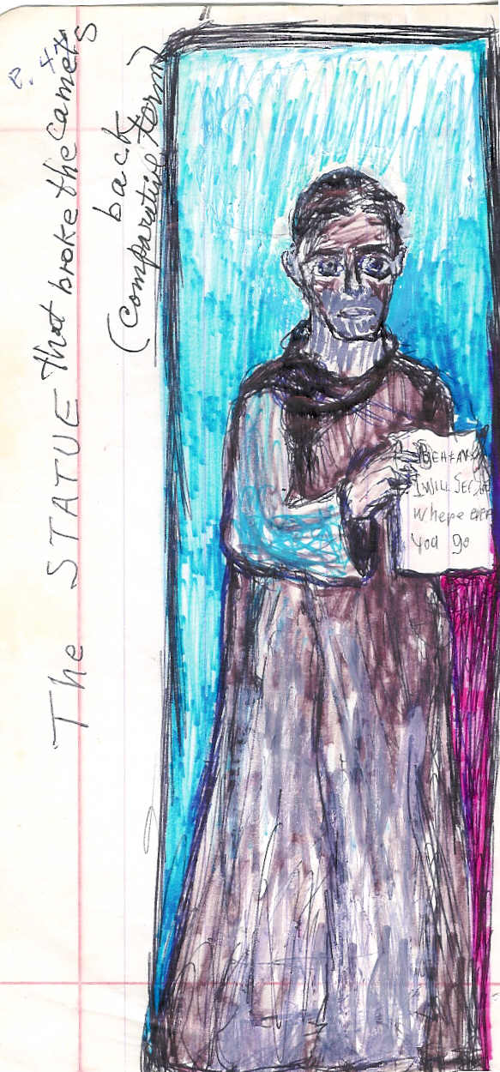
But now, hold your horses, here comes another surprise. On the south side of our house was a long corridor with arches separated by columns and in front of each column there was a statue or some kind of decoration. Each column had something on it except for one.
Then one day they came in with a new statue for the column. The statue was of a man wearing a long, dark gray robe. We were told that this statue spoke with his eyes. The statue was holding between his hands a placard with some writing on it. Paraphrasing, it read like this: Beware for I will be following you to wherever you go and when ever you come.
A terrible feeling or terror and uneasiness invaded my whole body, for every time we walked by him, his eyes turned toward our direction. If we went right, his eyes turned right, if we turn left his eyes would follow to the left. We avoided going toward the area all together where the statue was, but one day I had forgotten my shoes outside the area. It was getting late, almost dusk, so my sisters volunteered to go with me and fetch my shoes. Aunt Tyrza said, “no, you stay in”, so I didn’t go. She asked why I didn’t want to go alone, and I said that I was afraid of that awful weird new statue. I just finished saying these words when she got furious and went straight towards the closet where the whipping belt hung.
My mind and body acted fast. Since I had sworn to my sisters that the next time she tried that on me I would go away for good, so I went ahead to keep my promise and ran away without any hesitation. I flew out the door and was followed by my two sisters. That really made Aunt Tyrza realize that she had gone out too far so she panicked to the point of screaming and calling our names. Aunt Tyrza called, “Tere and Petra, come over here.” She also called Grandpa Luis all in one breath. “Please call the girls,” she said, “they are running away.” We were quick and went running down the hill like a flash of light. When we got to the manger we made a little stop, running water was coming down fast and many horses were about.
We sat among some big rocks to rest a little and recuperate. We decided that we would never go back to that nightmare of our lives. It was getting dark; we were just resting when our nice grandfather and a man appeared before us. They brought along two more horses. He promised us that if we were to go back to the house for that night, in the morning he would take us to the promised city, and that Aunt Tryza was highly repented of her mean behavior. She had promised never to touch us again. So we accepted this and went back home.
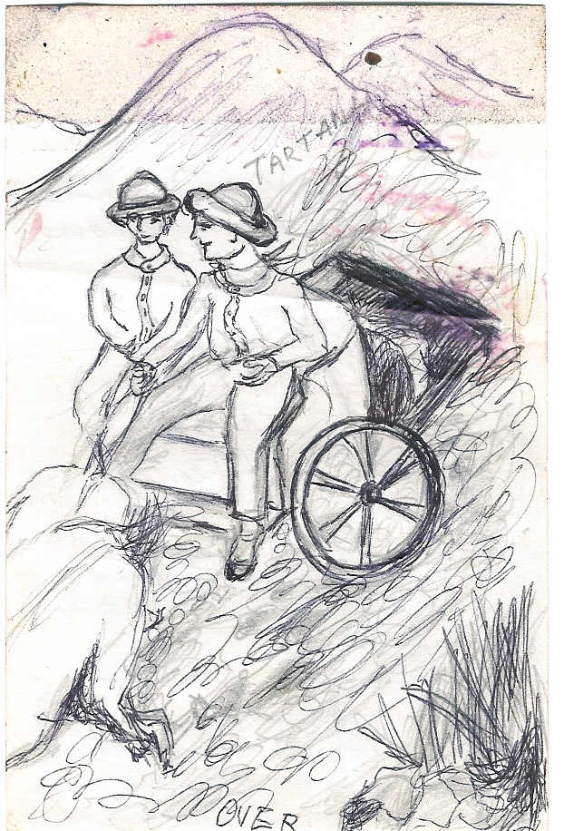
When we got there Aunt Tyrza came out to receive us with a big smile and tears in her eyes. She lied and said that she was getting the lantern from the closet to help me get my shoes. So we forgave her and she forgave us.
The next day a miracle happened, my father and brother Miguel had gotten back with an empty tartan, and after being informed of the present situation, he decided to go with us the to the city and stay till we found accommodations or dwelling with a good family. In the morning all we prepared for our trip.
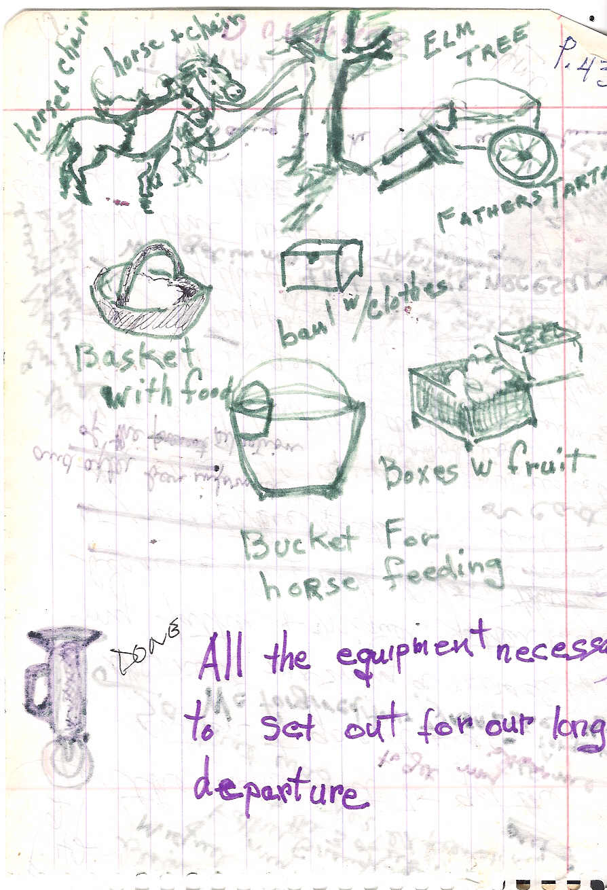
We left on good terms and Aunt Tyrza stayed home to take care of the necessary things.

We got on top of the tartan (wagon) and got a good view of the Sierra de Durango which was the last time we ever did. 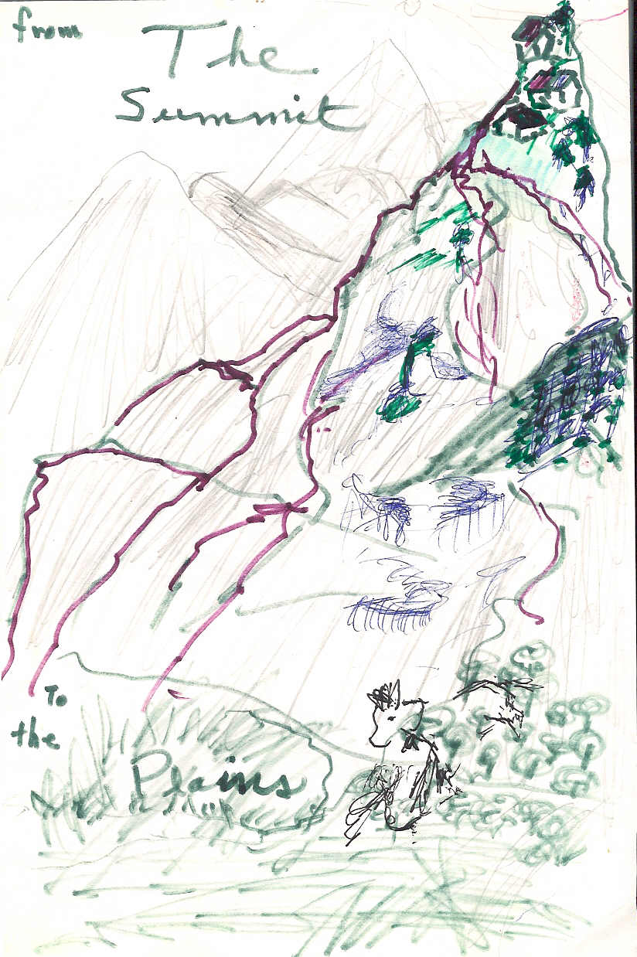
My dad’s cart was comfortable and Miguel was happy driving it. Grandpa mounted on his horse. He looked very dignified and happy. He was a man of great character and resistance. My father was riding ahead of the caravan and sometimes we would cross the road on foot and help with the animals crossing on the rugged mountains. We finally made it to the flat lands, where a new world was before us, and a new future. Hallelujah for flat land. This was the first day of October 1873.
I never even thought about how it would be, living in any place other than the rugged land of the Tamazula Mountains where you feel on top of the earth. Since we were born and raised there, away from society, the opposite happened when we arrived in the city of Culiacán. There, the town becomes overwhelming. One just has to adjust to it. You are never alone. The city has policemen, helping to organize everything. No longer are you your own police. The same applies to the government since you no longer make your own laws. The houses were all orderly, arranged in a line, one after the other forming rows called streets. As you get closer you discover this vast plain of land, or plateau. The city was bathed by the fresh waters of two large rivers where the confluence met at the center of the city. Many people were living in old houses, and others were just building their houses. It was the birth of the city. Our first meeting or encounter, once away from the mountains and arriving at the city, was our arrival at Amador’s home. The impression was fantastically comforting, warm and gracious. The families were very decent people, very receptive and friendly and quite wealthy. The Amador family consisted of two sisters, Rose and Susanna, and her husband.
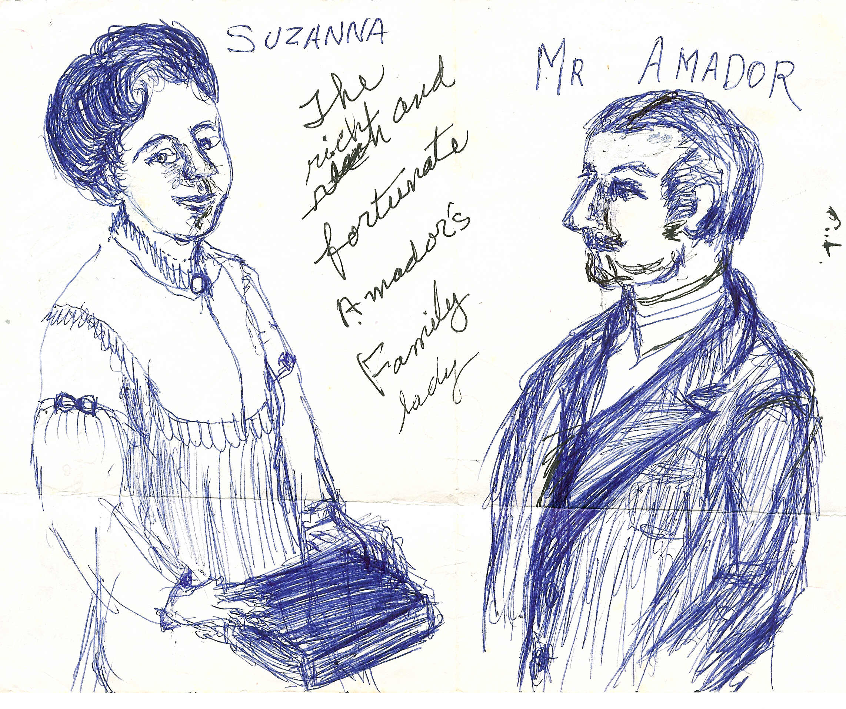
They said that they wished for us to live with them all the time. Mr. Amador was the owner of “Vias Amador”, a steam ship company, which was used to transport products. They transported cocoa and brought other commodities home. The house composed a whole block of buildings, one side was all arcades and the other side fronted the then future building of a beautiful cathedral with a large garden. After looking around and getting familiar with the surroundings we came in for supper. Their employee dined with us as well. The dining room was luxurious. After a great meal we all went to sleep. We three sisters shared a room that overlooked the courtyard with a little fountain in the center. Our father, grandpa and Miguel slept in another room nearby.
The next morning they spoke about the status and plans for the future. Susanna, the lady of the house, said she would be very happy to accommodate us in anything that would be needed for our stay. So we offered to work for them and they accepted with admiration. They needed a family or friend to take over the many things that they managed. Upstairs was a little factory where coffee was roasted and cocoa and sweet chocolate bars, “pastilles” where made. We were overwhelmed with glorious pride. We hugged one another with love. Susan said, “Now we have accomplished what we have always wanted in life. We have three beautiful girls. We love you as we did your beautiful mother. Let’s start getting acquainted.” So that opened the first chapter of our new life. As the days passed, we began to feel loved and comforted. We started to mold our life to a new way of living. With Susanna’s good character, we could ask questions without feeling that we were going to get hit or slapped, as it had been with Aunt Tyrza. That also included getting sick or working at our own pace. We were allowed to sing while we worked. In spite of all these comforts, we sometimes thought with sadness back on the beautiful mountains and cool fresh weather. We especially missed our brother Miguel, whom we loved so much. Months went by and by and we only received one letter from back home. They promised to come and visit us very soon, or as soon as the weather improved in the spring. Now with spring here it was easier for them to come to the city and trade the fruit. But, no word was heard from home until one day, after summer was over, brother Miguel appeared. We ran and hugged each other and cried. He told us the tragic news that Grandpa Luis had died. His mules had run wild after a swarm of king bees had attacked them. He had fallen down from the highest cliff and was never recovered. That was a very sad day for all of us. After we had recovered from the shock of the sad news, we also learned that Aunt Tyrza was very sick and wanted to see us girls. With Miguel leaving to stay in the city, she was unable to take care of the orchards. She now needed us home.
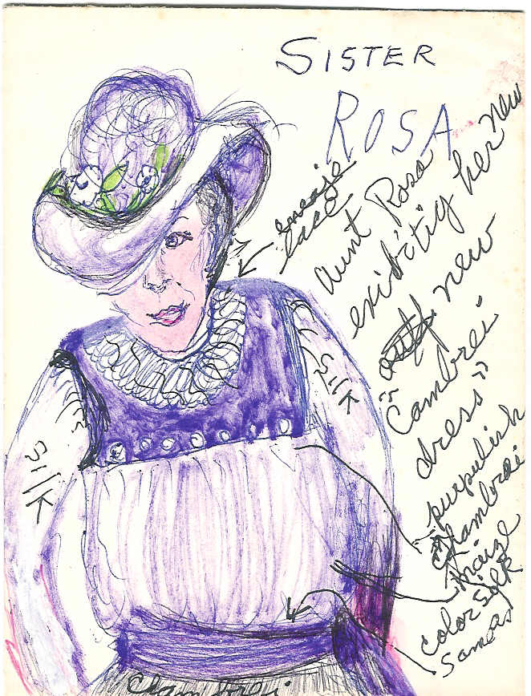
Our daily routine at work was like an elixir that alleviated our pain and sorrows and we realized that our future was over. Here we would just stay and help Susanna and Aunt Rosa. By now we had learned how to turn on the boilers, melt the chocolates, process the cocoa and roast it. We had also learned many European recipes from the Amador sisters who now we call Aunt Rosa and Aunt Susanna. We were also taken to the forest where they had other business. We visited workers and met families and friends that lived there.
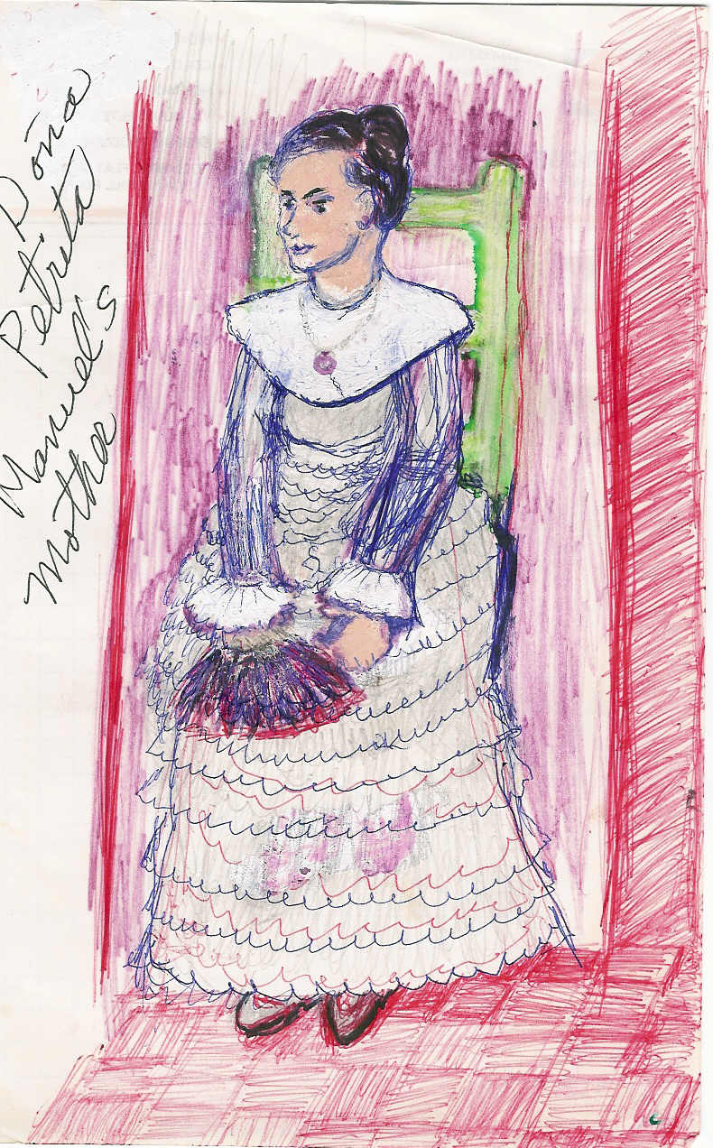
One was the Coultier family, which were Amador cousins. We tried to compensate them in our own way for all of their good deeds, but never could forget that we were nothing more than friends to the Amadors and the other families. We were invited to refrigerios, or teatime. The closest family friends were the Coultiers. Doña Petrita de Coultier was a very well educated and sweet lady that took a fancy to Efren and invited her to the plantation.
Their plantation was on the other side of the river, which we crossed in one of their two coaches. The chauffeur was a fellow named Jeyo.
One day the son, Manuel came home from Europe, where he was attending college studying to become a chemist. He took me to his girlfriend’s birthday celebration where he introduced me as cousin Efrena. I was so attracted to him. He was very handsome.
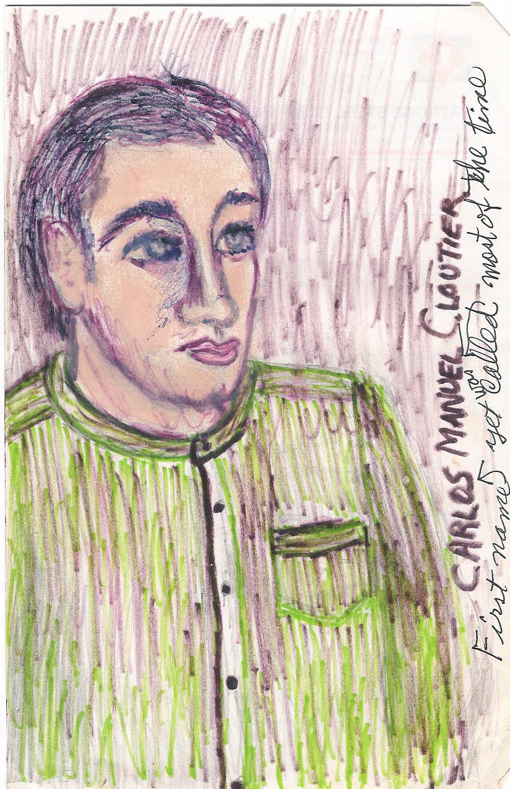
I had to suppress all my feelings for him, especially when I would sit and serve his coffee at refreshment time. His mother, Doña Petrita, liked me a lot. One day Mrs. Amador came in and said that Petrita needed me to accompany her to her family’s farm and bring back her mother, who was coming to the city to spend a month with the family. Of course I agreed. Manuel was coming also. That morning I kissed Mrs. Amador and left with the Coultiers. I carried with me a basket of chocolate rolls for our trip. When I arrived at their home, I noticed that Petrita was sitting in a chair with her foot up in the air and in great pain. “Come in” she said, “I cannot walk, I just twisted my foot”. Her foot was very swollen and she could not make the trip to pick up her mother who was waiting for us. So, Manuel, Jeyo and I left to get her mother. So we left in haste, the two men seated in the front of the coach and I, in the back by myself. I slept a little and then woke up to see the two men trying to lift one of the coach horses from the ground. The animal wouldn’t move. One of the shoes was broken and needed to be removed and replaced. Manuel had to go and get a new one made. I was going to go with time, but the sky looked dark and ominous and suddenly the rains came down by the bucket, giving rise to a huge storm. Jeyo, the chauffeur, volunteered to go instead. Manuel and I waited in the coach for his return. It took a long time for his return, so we ran looking for shelter in a small barge, which we had seen a short distance away. Manuel found a way to enter and opened the door. The house was unoccupied and there was a large table with two candles, which Manuel commenced to light. All kinds of thoughts ran through my mind, seeing him so close to me in that candlelit room. Morning came and Jeyo had never returned. The reason? The bad storm. So, nature took its course and the inevitable happened to us. Manuel was so romantic and we really felt that we were in love, ignoring status and restrictions. How about Manuel’s mother? Well she was back home taking care of her foot. And what about Jeyo? Well he finally came back the next day and put the new shoe on the horse so we proceeded on our trip to bring Grandmother home. Not much detail about that romantic night but, Manuel and Efren went on with their romance. Mrs. Petrita continued as always, to be sweet and sincere.
Meanwhile, how about Efrena’s sisters? They had found families that needed companions and Mrs. Amador happily shared them. Tere always liked to sing religious psalms. She was living with a family she befriended and sang in the church choir on Sundays. The oldest sister, Petra, was hired as a steady seamstress for the Alma de la Rocha family, who lived on the outskirts of the city and owned a factory that made artificial flowers and ricotta cheese, which was packed in boxes and shipped. Petra had the dexterity of a dress confectioner but in spite of having been fortunate in this way, destiny drew her into a different and lamentable case, if you look at it that way. It all started when she was left alone in the house for ten days, in charge of and representing the owners. She started to boil a big pot of water to sterilize some bottles for canning. She was happily singing like a jilguero pajarillo (a singing bird), when suddenly the entire picture was reversed by a loud cry of Tere. She had tripped the kettle and the hot water spilled all over her right leg, part of her chest and her right hand.
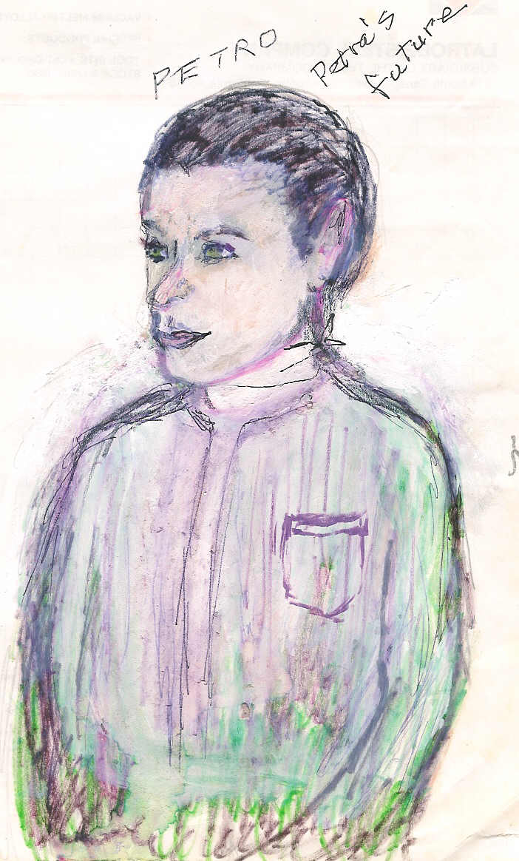
Petra was busy all of the time and did not have much time for diversions. She was doing so very good that one day, she let Doña Lena go home to visit her family for 5 days. Doña Lena lived on the property to serve as a guard of the back side of the property and to guard the gates and open them for deliveries and close and watch the garden. In her absence, Petra happened to open the gate to Petro, the wood deliveryman. It was a Thursday and Petro was surprised when beautiful Petra approached the gate. When she closed the gate he could hear the rustle of her silk blouse. In his mind he had a fantasy of receiving a hug from her but he said goodbye. Three days later he had to make another delivery. When he was through delivering the wood, Petra went to close the gate, securing it. He said, “Thank you Petra”, and she smiled.
Although he was only a wood deliveryman, she thought that he had the grace of a Prince. He made quite an impression on her. He too could not forget or erase the lasting impression of the gracious movement of her blouse as she opened the gate for him. The next day he decided to deliver more wood, just to take a second look to comfort his emotions. Petra again helped him at the front gate. He continued to deliver wood for the household and the two continued to meet in this way.
One day, Petra was busy finishing a new blouse for the Sunday festival. She tried on the silk that had such a nice feeling. The soft beige color suited Petra’s lovely complexion and the soft green buttons matched her beautiful eyes. It was just then that someone called at the front gate. It was the man delivering a new batch of wood. As he approached the front door, he could hear the agony of this sweet girl’s loud moaning. Petra had dropped the heavy burning iron on her bare foot and as she was trying to push it away she had also burned her hand. Hearing her cry, he waited no longer. He impulsively jumped over the fence to find her semi fainted on the floor. He thanked God for the opportunity to be there and proceeded with an emergency treatment. He immersed her foot and hand in cold water, then, doing all he could, he cooked her some soup. The next day, he repeated the same thing. Petra was immensely grateful. Caught between the fantasies of the prohibited fruit, Petra felt her feelings grow more and more for him everyday. Unfortunately, it would be impossible to date him, for the Amador family wouldn’t even consider him looking at her. But conflicts are always emotional and this was a conflict for this couple.
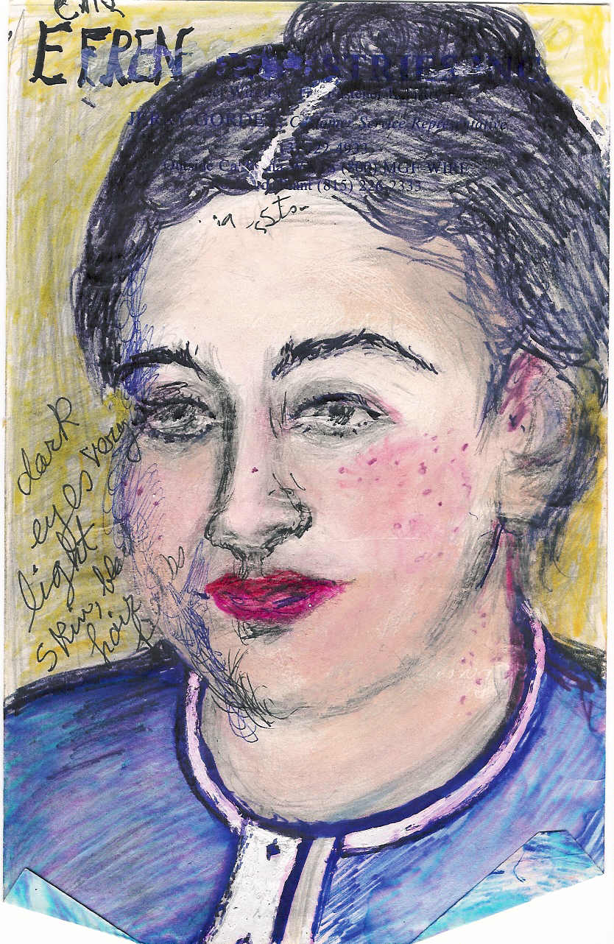
Now going back to Efrena. She was waiting all the time for Manuel to return from Europe. She was expecting a baby and up till now she was the only one who knew it. But time passed and she began to get big, so she ran away to avoid the embarrassment of having the Amadors know her secret trouble. Efren’s problems grew more and more, as she soon had her second baby, this one from almost a violation. Then, her boyfriend died when the ship was wrecked on the way back from Europe. She was told that the boat had sunk. Efren only got some leftovers; some real estate, only vacant land, to compensate for some support for Manuel’s baby. Efren was still beautiful and of strong character in spite of her bad luck. She organized her life but word got around the neighborhood that she was well off. To her misfortune, she suffered several attempts on her life. Here is the story of one of them.
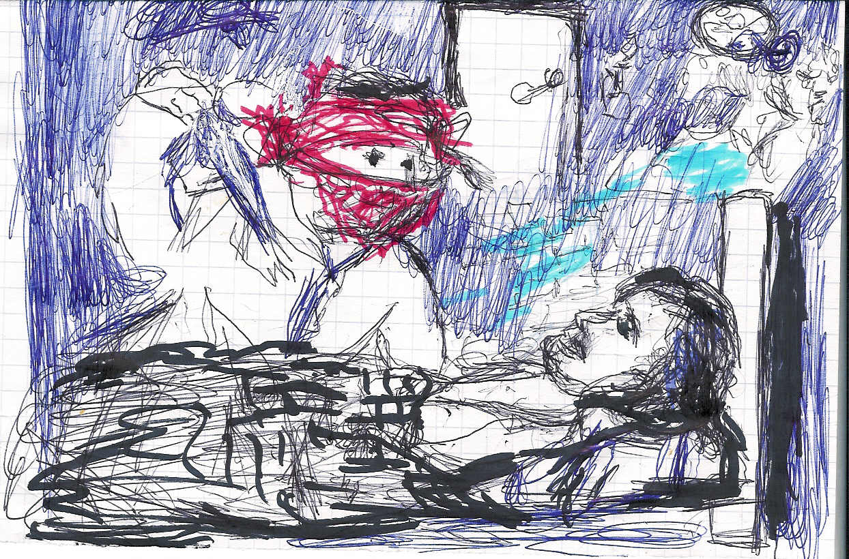
Efren lay in bed in the final hours of the day. She was sound asleep when suddenly she was awakened to find herself facing an ugly hoodlum. His face was completely covered with a red handkerchief leaving only enough space for his eyes to show. His right arm was up in the air holding a dagger. She quickly translated that picture to understand his intention; the results of being a hungry, ill cultured fellow. She quickly responded with an attractive solution saying, “Don’t kill me. If it’s money that you want I will give you all that I have.” The stranger responded, “Yes, give me money and you will be safe.” She calmly said, “Let me get you the key to the coffer,” and pulled herself away to go for the key, but instead, she ran out the front door, yelling, “Help, help. A killer is here.”
To her rescue, a Sereno, or nightwatchman, came, and with his loud whistle, called for more help. Now Efren found herself out in the street barefooted and dressed in her old gown, scared and trembling. All the neighbors were also out, but the bandito disappeared through the back yard. This last episode caused her to desire a new husband and find one she did.
She married a handsome fellow and kept him till her death. Now, after her two sons, she had a baby girl and named her Antonia, then six years later another baby boy whom she named Jose Merced, after her salvation or merciful return to life. As is typical, the older boys resented their stepfather so they ran away from home to develop and grow up on their own. This sadness caused Efren to die relatively young. Her daughter Antonia was a very pretty girl who eventually married and had four children. She had a good life and lived to be 101 years old.
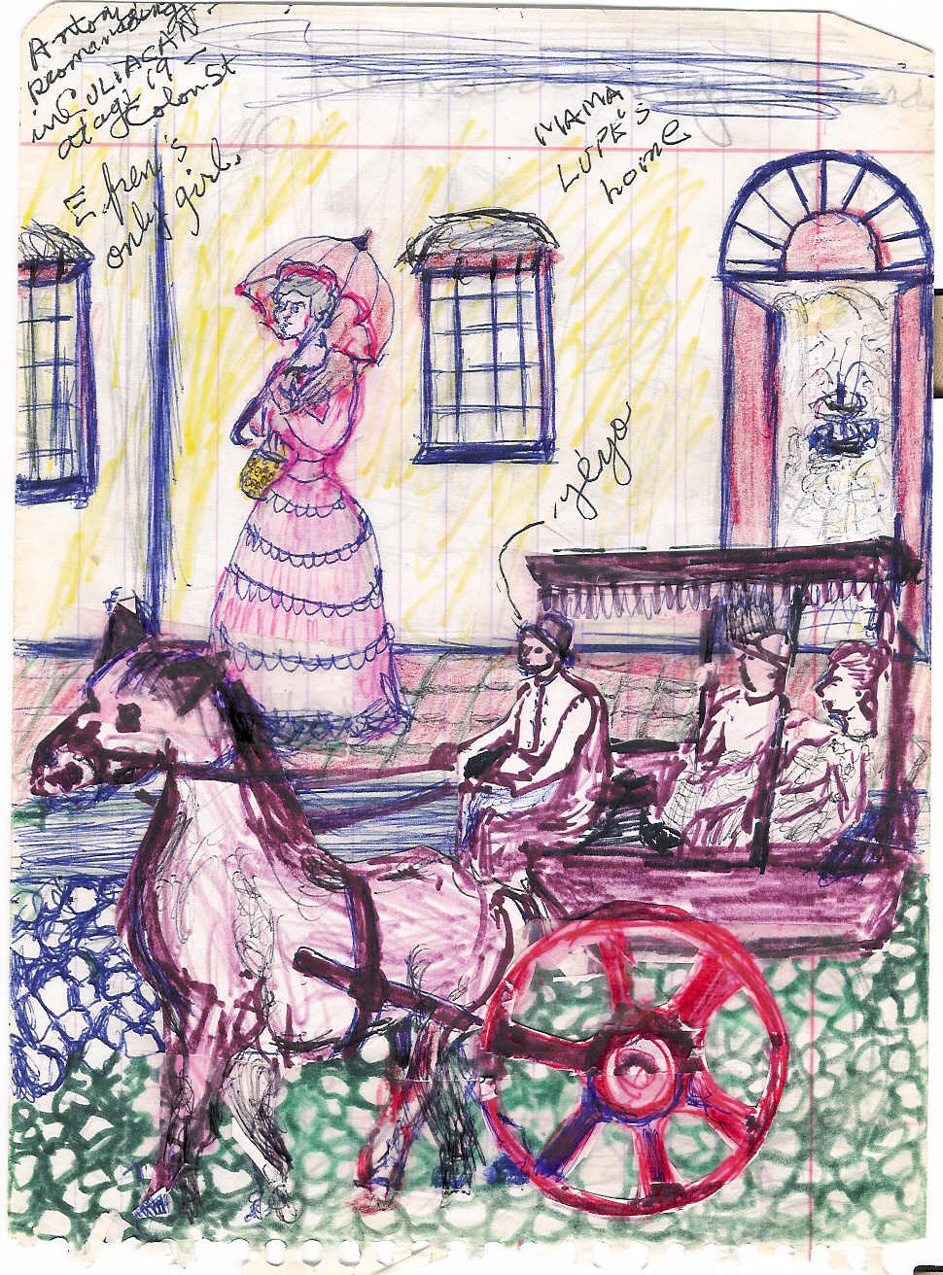
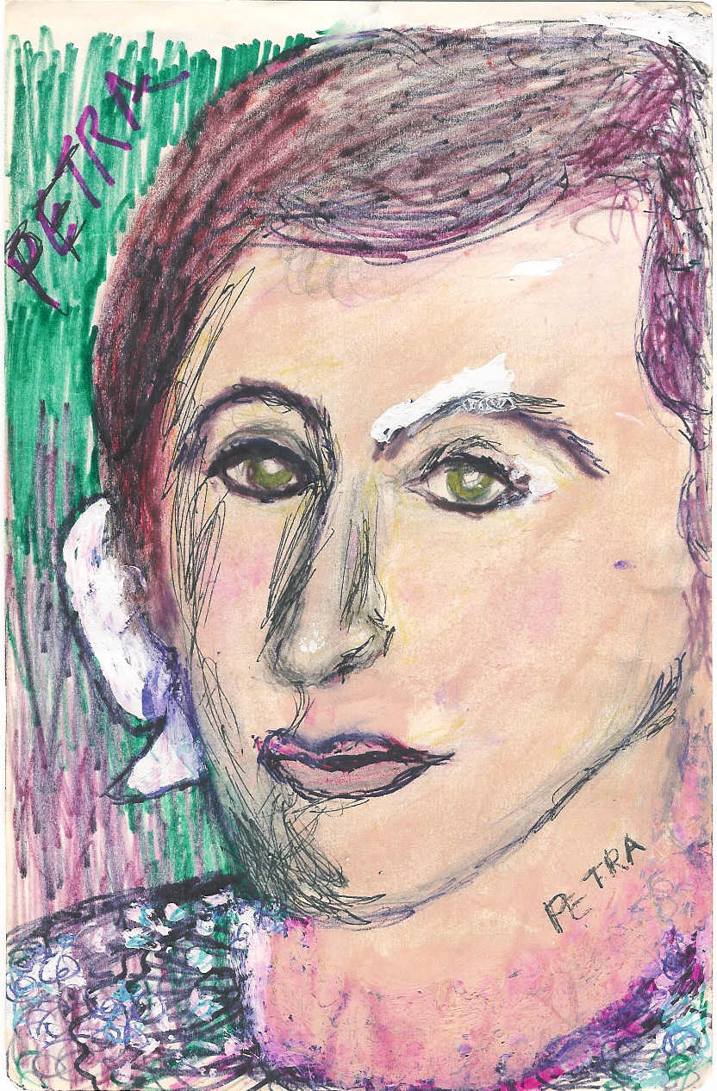
Now, back to Petra. A customer appeared in her tiny but very interesting little parlor store, where she designed and sewed beautiful dresses, and she hired him to work as her companion and protector. He remained as such for a while until he converted himself for love as her husband. His name was Antonio. He was very young and strong and very, very handsome. I thought this was a cute little episode to take part of this historical narration in lieu of many other ones of less importance.

And so here I conclude this last chapter. I first want to express my most sincere gratitude to you my reader out there for accompanying me in this trail of the past. I was inspired in short anecdotes told by my mother. Her mother couldn’t read or write but had a strong desire to communicate to the world all the problems and perils faced by everybody but in particular, being an orphan. Nevertheless, I hope you have been amused in some way and have added one more experience to the files of your life. There are other chapters dealing with the separate lives of each of the three sisters. And what became of brother Miguel? Sadly, he fell to his death from about a thousand feet high while working in the church construction.

